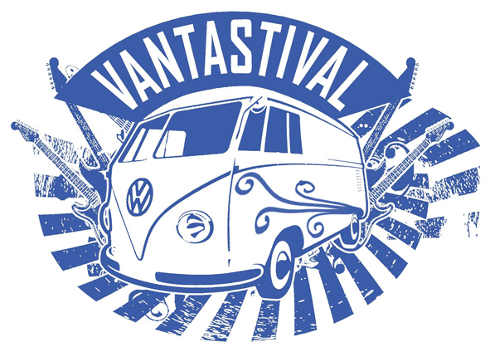
VANTASTIVAL VOLUNTEER FORM

We have many volunteering opportunities at Vantastival. Volunteering is a great way to be involved in the festival, meet new people and gain some experience in the field. Volunteers receive a free ticket for the weekend in exchange for two 6-hour shifts over the course of the festival. Each volunteer will be required to pay a deposit of €65 which will be returned to you on Sunday or once you have finished your final shift. This is a policy operated by all festivals to ensure volunteers show up for their designated shifts. Volunteers will be required to be on site at 10.00am, Friday 3rd June for induction and training.

Please complete the following form and return it to louise@vantastival.com. Feel free to add an extra page if necessary to tell us about yourself.

Name: | Date of Birth:
Address: | Email:  Phone:
Tell us a little bit about yourself:

Any relevant previous experience:

List any particular skills you might have: (eg. carpentry, décor, working with children, admin, first aid etc.)

Do you have any disabilities or mobility issues?

Some roles require volunteers to lift items, can you indicate if you are willing & able to lift a reasonable weight:

TERMS AND CONDITIONS

- All volunteers must be 18 years old or more at the time of the festival.
- Volunteers MUST show photo ID on entry to the festival. Entry will not be granted without ID.
- Volunteers must comply with all site safety requirements. All volunteers must complete a Health & Safety Induction on arrival on site. This will cover site safety and regulations. Volunteers are required to wear a Hi-Vis jacket at all times while on duty, which we can provide for you with a €10 refundable deposit.
- Volunteers are advised to dress for the Irish weather. This means bringing warm clothes, suitable & comfortable footwear, sun cream, sun/rain hat etc
- Volunteers must commit to a minimum of 12 hours work during the festival. All volunteers are required to pay a deposit of equal value to a full weekend camping ticket. This will be fully reimbursed to you upon completion of your designated shifts. You must complete all shift requirements or risk forfeiting your deposit. If you are unable to do a shift due to illness, injury or family emergency, you must contact the Volunteer Coordinator immediately.
- Drinking alcohol while on duty during shifts is absolutely forbidden. Drinking on duty or showing up for a shift whilst inebriated may result in you forfeiting your deposit.
- Drugs are illegal and are forbidden on the festival site. Anyone who shows up for a shift while under the influence of drugs may result in you forfeiting your deposit.
I have read the information and agree to its terms

Signed ____________________________ Date__________________

